Large-Scale Associations of BMI and Clinical Obesity With Cardiac Field Artifact in Scalp EEG
Nir Cafri^{1,3}, Felix Benninger^{2,3}, Pablo Blinder^{1,2}
¹Department of Neurobiology, School of Neurobiology, Biochemistry and Biophysics, George S. Wise Faculty of Life Sciences, Tel Aviv University, Tel Aviv, Israel
²Sagol School of Neuroscience, Tel Aviv University, Tel Aviv, Israel
³Department of Neurology, Rabin Medical Center, Beilinson Hospital and Tel-Aviv University, Petah Tikva, Israel
Correspondence: nircafri@mail.tau.ac.il

Supplementary analysis

S1. Cohort composition
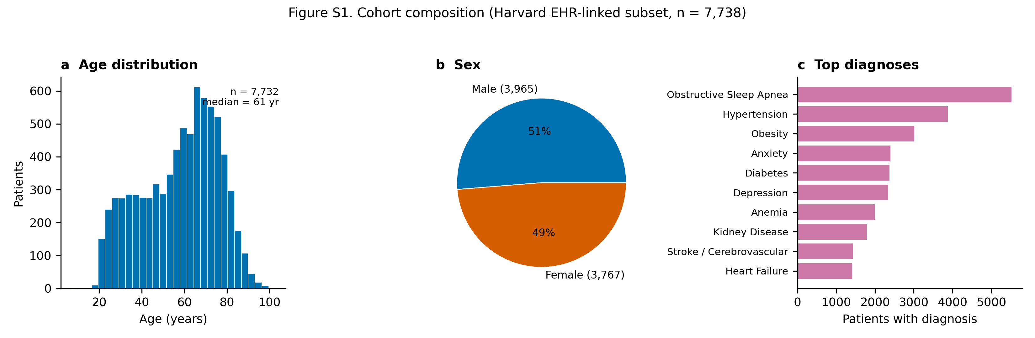
Figure S1. Cohort composition of the 7,738 EHR-linked patients. (a) Age distribution (median 61 years, range 7-103). (b) Sex (Male n=3,965, Female n=3,767). (c) The ten most prevalent broad clinical diagnosis categories, of which the largest were Obstructive Sleep Apnea (n=5,524); Hypertension (n=3,882); Obesity (n=3,016). This is a clinically referred polysomnography population, not a healthy community sample; diagnosis categories are not mutually exclusive.

S2. Variance and entropy vs. a non-heartbeat-locked noise floor
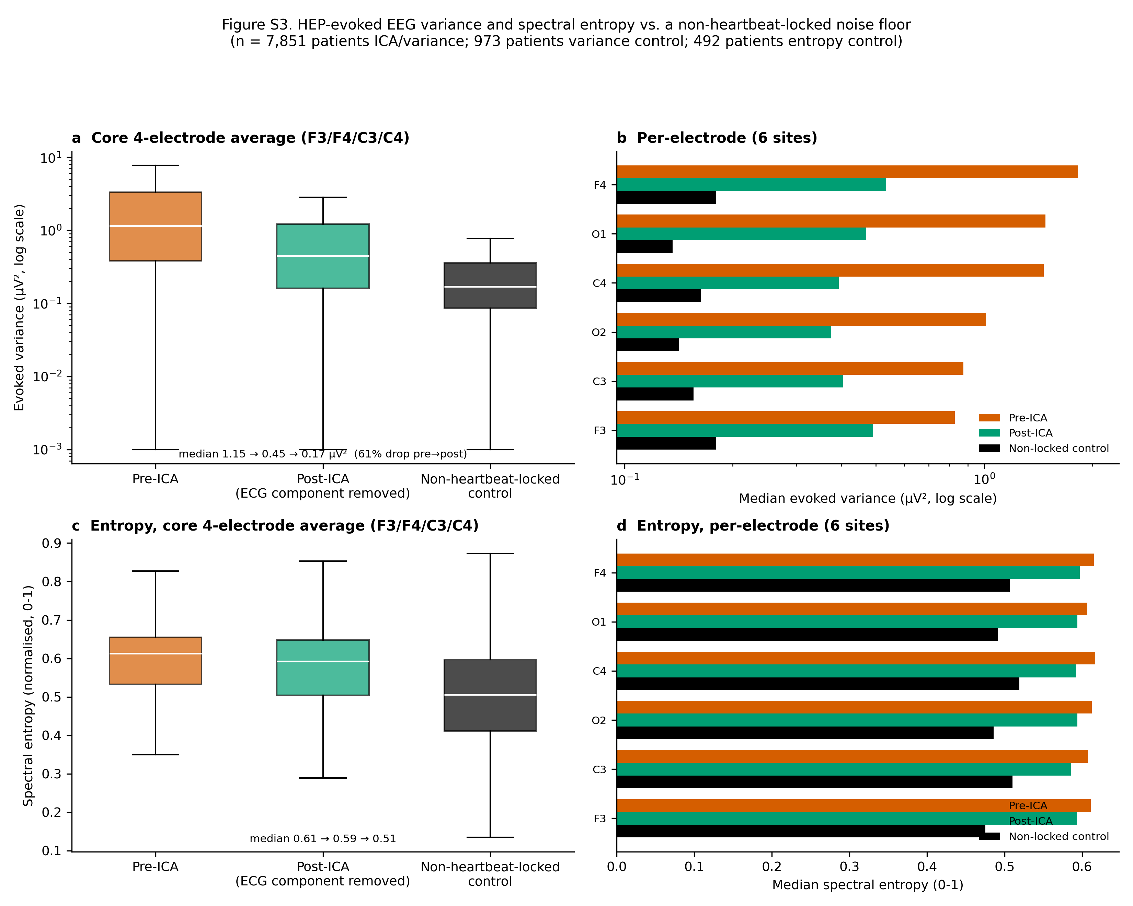
Figure S2. Absolute HEP-evoked EEG variance before vs. after excluding the ECG-flagged ICA component, alongside a non-heartbeat-locked control (n = 7,851 patients ICA; 973-patient control subsample; distributions are right-skewed, so medians on a log axis are reported rather than means). (a) Averaged over the core bilateral frontal-central quad (F3/F4/C3/C4): median 1.15 µV² pre-ICA to 0.45 µV² post-ICA (a 61% drop) vs. 0.17 µV² for the non-locked control — the same quality-controlled windows re-epoched around random pseudo-events instead of true R-peaks. (b) The same three-way comparison broken out per electrode, all six sites (§2.6). (c) Spectral entropy (normalised Shannon entropy of the evoked waveform's Welch power spectrum, 0-1) of the same three conditions, core electrode average (n = 492 patients, separate subsample). (d) Spectral entropy per electrode.
Removing the flagged component cut core-electrode HEP-evoked variance by 61% at the median, consistent with the fractional cleaning-effect reported in §3.2 (median 28%). The non-heartbeat-locked control gives the finite-sample noise floor this comparison is measured against (0.17 µV²), well below both pre-ICA (1.15 µV²) and post-ICA (0.45 µV²) — both still contain genuinely R-peak-locked structure, and post-ICA sitting clearly above the floor at every electrode (panel S2b) shows the flagged component's removal did not simply average the signal down to noise. Spectral entropy gives an independent, variance-free view of the same comparison: entropy fell from pre-ICA (0.61) to post-ICA (0.59) to the non-locked control (0.51), dropping only partially from pre- to post-ICA and remaining above the control at every electrode (panel S2d) — reinforcing §3.2's conclusion from a second, independent signal property.

S3. How much of the EEG is heart data: cross-correlation and mutual information
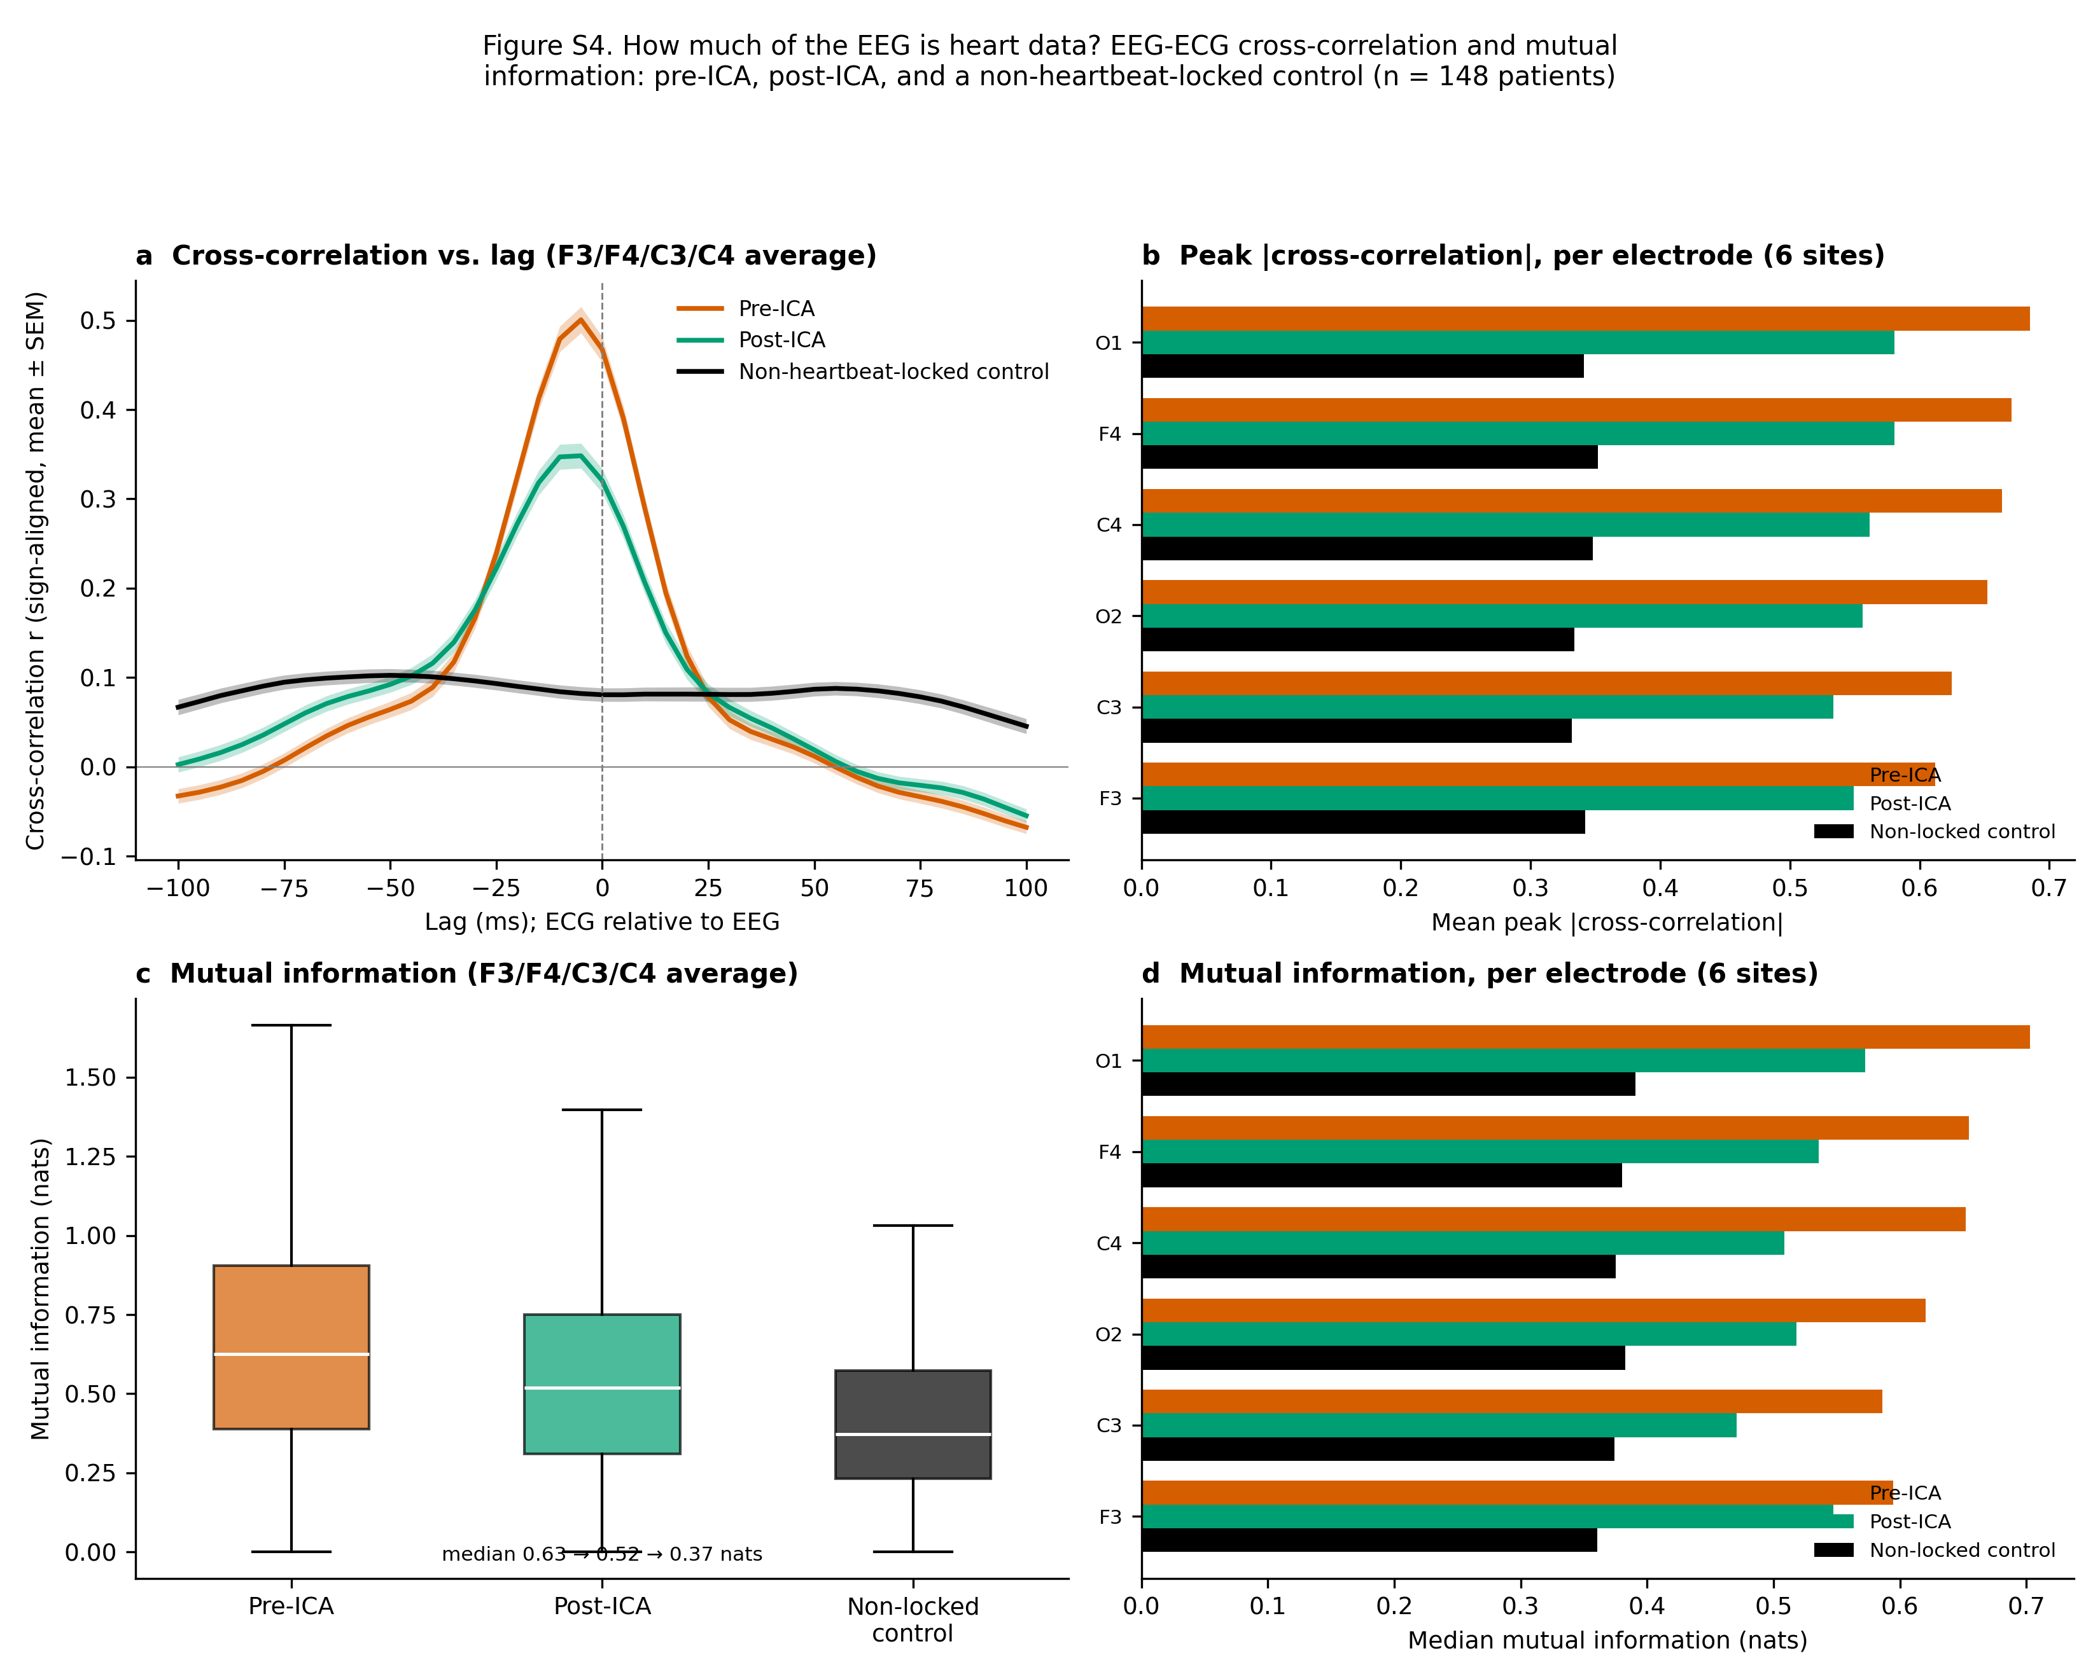
Figure S3. How much of the EEG is heart data: EEG-ECG cross-correlation and mutual information, pre-ICA, post-ICA, and a non-heartbeat-locked control (n = 148 patients, separate subsample re-fitting ICA to recover the paired evoked waveforms, which the main batch does not persist; §2.7). The control re-epochs the same pre-ICA EEG around random pseudo-events instead of true R-peaks and correlates it against the same real R-peak-locked ECG evoked average — the chance-level relationship expected if the EEG evoked waveform carried no genuine R-peak-locked structure at all. (a) Lag-resolved cross-correlation between the core-electrode (F3/F4/C3/C4) HEP evoked average and the concurrent ECG evoked average, sign-aligned per channel before averaging (reference polarity is arbitrary; magnitude is not) and shown mean ± SEM across patients. (b) Mean peak |cross-correlation| (maximum over lag) per electrode, all three conditions. (c) Mutual information between the same waveform pairs, core-electrode average. (d) Mutual information per electrode.
Cross-correlation peaks close to zero lag in both real conditions (median peak lag -5 ms pre-ICA, -10 ms post-ICA), consistent with the near-instantaneous volume-conduction assumption behind the zero-lag regression estimator (§2.3). Peak correlation strength drops from pre-ICA (mean |r| = 0.64) to post-ICA (mean |r| = 0.56) to the non-locked control (mean |r| = 0.34), and mutual information drops the same way, from 0.63 to 0.52 to 0.37 nats (panel c). Post-ICA sits clearly above the non-locked floor at every well-covered electrode (panels S3b, S3d): a non-trivial EEG-ECG relationship remains after cleaning, the same conclusion the realised cleaning-effect view (§3.2) and Supplementary Figure S2's noise-floor comparison independently reach. Because mutual information captures nonlinear as well as linear dependence, its post-ICA persistence rules out a nonlinear EEG-ECG relationship invisible to zero-lag Pearson correlation explaining away the R²-based result (§3.2).

S4. Power spectral density: pre-ICA, post-ICA, non-locked control, and ECG
A fourth view of the same question: the raw spectral shape of each evoked waveform, rather than a single correlation or variance summary. Welch power spectral density was computed on the same pre-ICA, post-ICA, and non-locked evoked waveforms as §S3, plus the patient’s own ECG evoked average, on the same 150-patient subsample.
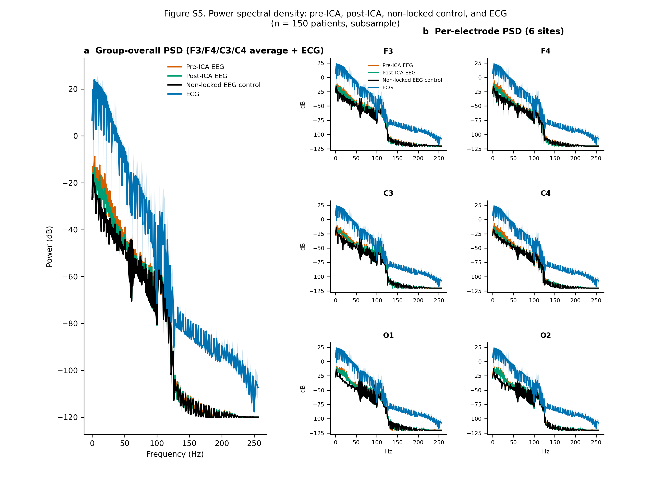
Figure S4. Power spectral density (Welch, dB) of the pre-ICA, post-ICA, non-heartbeat-locked control, and ECG evoked waveforms (n = 150 patients). (a) Group-overall: core 4-electrode (F3/F4/C3/C4) average, all four conditions overlaid (mean ± SEM). (b) Per-electrode: the same four-way overlay for each of the six well-covered sites (§2.6).
The ECG's own spectrum is broadband and structured (dominated by the QRS complex's sharp transient) compared to the flatter non-locked EEG control. Pre-ICA and post-ICA EEG spectra sit between these two references, both shaped more like the ECG than like the non-locked floor — a spectral-domain view of the same conclusion as §3.2 and §S3. Spectral shape is broadly similar across the six electrodes (panel b), consistent with Figure 2's finding that CFA varies in magnitude but not qualitatively in character across the scalp.

S5. Is the sex effect on CFA R² confounded by BMI?
Male patients had higher CFA R² than female patients (§3.4), and men in this cohort skew heavier, raising the question of whether the sex gap is really a BMI effect. On the BMI-available subsample (n = 6,127; derived from EHR height/weight vitals), an OLS regression of patient-mean CFA R² (outside QRS) on sex alone gave a male-vs-female coefficient of 0.031 (95% CI 0.020 to 0.041, p = 1.1e-08); adding BMI as a covariate left the sex coefficient essentially unchanged, 0.040 (95% CI 0.029 to 0.050, p = 3.2e-13), while BMI itself was an independent, significant predictor (coefficient 0.0029 per BMI unit, p = 1.5e-21).
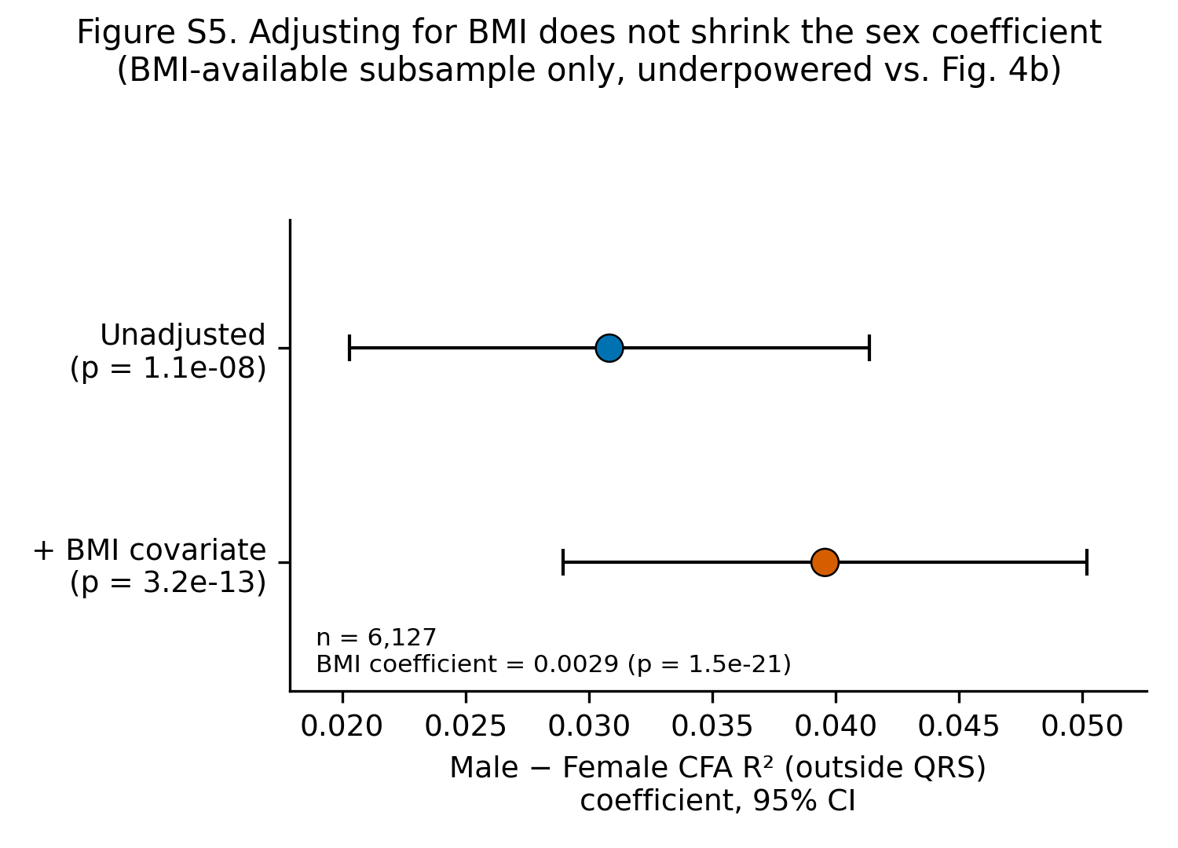
Figure S5. Male-vs-female CFA R² (outside QRS) OLS coefficient, unadjusted vs. BMI-adjusted, same BMI-available subsample (n = 6,127); points = coefficient, error bars = 95% CI.
The sex coefficient does not shrink after adjusting for BMI — if anything it is slightly larger — which argues against BMI being the driver of the sex effect seen in the full cohort. Although this subset is smaller than the full sex comparison (n = 6,127 vs. n = 7,729 in Figure 4b, which reached p = 1.5e-21), the expanded matched analysis now estimates both the unadjusted and BMI-adjusted sex coefficients precisely (p = 1.1e-08 and p = 3.2e-13, respectively). BMI and sex therefore contribute independently in this observational model; adjustment does not support BMI as the explanation for the sex gap.

S6. Time-domain sensitivity to recording duration
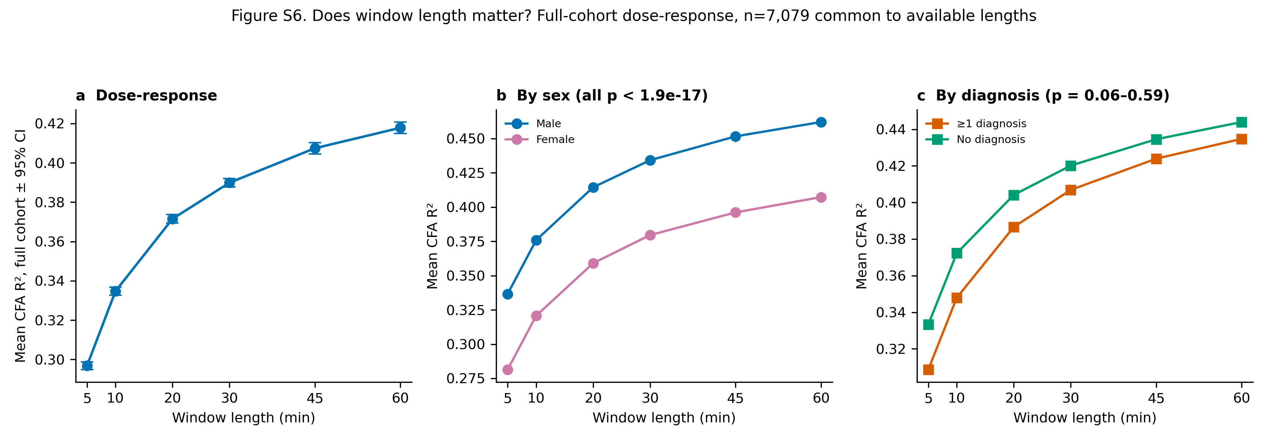
Figure S6. Time-domain sensitivity of CFA estimation to recording duration (n = 7,079 patients with usable data at every duration). (a) Mean CFA R² at 5, 10, 20, 30, 45, and 60 min (5 min: 0.30; 10 min: 0.33; 20 min: 0.37; 30 min: 0.39; 45 min: 0.41; 60 min: 0.42). (b) Sex-stratified and (c) diagnosis-stratified estimates. The sex difference was present at every available duration (Mann-Whitney, all p < 1.9e-17); diagnosis differences were not significant (p = 0.06–0.59).
Recording duration had a clear time-domain effect on the detectable cardiac contribution. Mean CFA R² increased from 0.30 at 5 min to 0.33 at 10 min, 0.37 at 20 min, 0.39 at 30 min, 0.41 at 45 min, and 0.42 at 60 min. Thus, 5-minute and 10-minute windows miss shared EEG-ECG structure that becomes detectable when more heartbeats are averaged. The incremental gain decreased from 0.04 R² units between 10 and 20 min to 0.02 between 20 and 30 min and 0.01 between 45 and 60 min, supporting a plateau after approximately 30 min. The sex difference persisted across all tested durations, whereas diagnosis differences were not significant in this matched subset.

